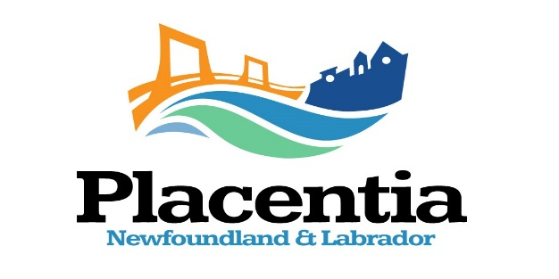
Strategic Plan Survey Information Circular
The newly elected Mayor and Council of the Town of Placentia are developing a new Strategic Plan to guide it in assessing the priorities that, you, the residents, and business owners would like them to address during their term of office.
The priorities will be reassessed on a yearly basis over Council’s term of office and include the steps required to accomplish them. Your input is vital to the development and success of the Strategic Plan.
Council has engaged LW Consulting to assist them with the public consultation and development of the Strategic Plan.
The Town requests your participation in the creation of its new Strategi Plan by completing a survey. This can be done by completing the attached Placentia Strategic Plan Survey (word document) which you can fill in, save, and email to lewis.gerard@bellaliant.net. You can also complete the survey by copying and pasting this link in your browser https;//www.surveymonkey.com/r/YVZD9PL If you encounter any difficulty in accessing either document please email lewis.gerard@bellaliant.net.

Thank you for completing this survey. It is an important part of the development of the Town of Placentia’s Strategic Plan which will guide it in addressing your priority issues over Council’s term of office.

Mayor Pearson and Council values and appreciates your participation in the Strategic Planning process. As a token of their appreciation, everyone who completes the attached survey will have their names included in a draw for a $100.00 Visa Gift Card.

Everyone will have another opportunity to participate in the development of the Strategic Plan at a Public Meeting at the Arts Centre on December 14, 2021, at 6:00 PM. An overview provided by LW Consulting will give the priorities you identified in the survey for Council to address during its term of office. You will have an opportunity at this meeting to add any additional comments you feel are relevant. This will provide Council with the priorities you would like Council to address during its term of office. This is important to Council so that they will be aware of your expectations. The draw for the $100.00 Visa Gift Card will take place at this meeting.

Upon completion of the Strategic Planning Process there will be another Public Meeting to present everyone with the Town’s new Strategic Plan. The Town will provide information on the place and time of this meeting.

At a Public Meeting prior to the end of 2022, a Report Card will outline Council’s accomplishments of the identified priorities included in the Strategic Plan.

Please complete the Survey before 4:00 PM, December 11, 2021.

